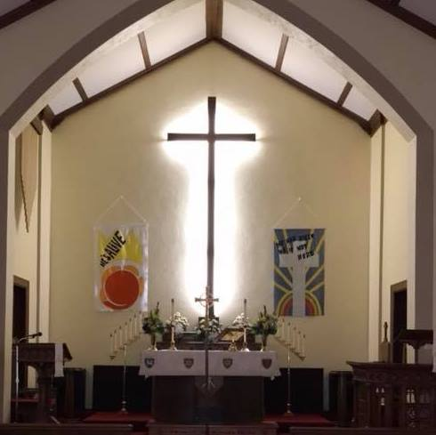

St. Paul GLEE Scholarship
(Gary Lundeen Education Excellence)

The St. Paul GLEE Scholarship is administered by the St. Paul Lutheran Church Scholarship Committee and the Gary Lundeen Family. The scholarship is for students attending or planning to attend an accredited college, university, or trade school. All recipients must meet the specified criteria. Scholarships will be used for tuition/room and board/expenses.

Gary Lundeen grew up in Missouri Valley where he was baptized and confirmed at St. Paul Lutheran Church. Education became a major part of Gary’s life as he became a teacher. His faith that started at St. Paul stayed with him through the Vietnam War and as he battled his illness for several years. Because of his faith and education, we would like to help our youth with this opportunity in his name.

Scholarship Criteria
Applicants for the St. Paul GLEE Scholarship, awarded through the St. Paul Lutheran Church Scholarship Committee and the Gary Lundeen Family must meet the following criteria:

- Be a confirmed member of St. Paul Lutheran Church
- Receive the scholarship at the completion of the first semester if you have a minimum 2.5 grade point average.
- Be officially accepted for admission to an accredited university, college or trade school;
- Enroll as a full time student each semester for an award;
- Participate in the life of St. Paul Lutheran Church through volunteer opportunities and documentation of your involvement. This includes worship assistant, committees, community table, community garden, VBS, Sunday School, etc. (See Section A)
- Write a short essay discussing how your moral, ethical and spiritual beliefs will impact your ability to make a difference in the world.( See Section B)
- Maintain a minimum 2.5 grade point average or better to retain the scholarship and to be considered for a new award.
- You can reapply- providing you meet the requirements.

SCHOLARSHIP APPLICATION

Please complete all sections of the application. No applications will be accepted after April 1, 2023

Section 1 – Personal Information

Name: Date of Birth:

Home Address: Guardian:

Home Phone:

Alternate Phone: (Optional)

Email Address:

Section 2 – Academic Information

Name of High School:

GPA:

High School Rank: out of

SAT/ACT Scores:

Anticipated Major (s):

SECTION A: List and briefly describe volunteer activities in which you have been involved with at St. Paul and other faith based communities.
ACTIVITY DATE OF INVOLVEMENT

SECTION B: Short Essay: Explain how moral, ethical and spiritual beliefs will impact your ability to make a difference in the world. Tell us of your goals and plans for the future. This might include what it means to you to be a Christian.

Participation in the Life of St. Paul Lutheran Church will be used to evaluate the amount to be dispersed.
Is there any other information that we should know about you? This is your opportunity to include information that is not contained in other areas of this application.

Blessings,
Scholarship Committee

Lisa Hember
Gretchen Long
Stacy Pippitt
Jennifer Ferris
Lori Clark

